**DAILY ONLINE ACTIVITIES SUMMARY**

|  |  |  |  |  |  |  |  |  |
| --- | --- | --- | --- | --- | --- | --- | --- | --- |
| **Date:** | **02/07/2020** | | | | | **Name:** | **NIKHIL KUMAR** | |
| **Sem & Sec** | **4thSEM. & ‘B’ SEC.** | | | | | **USN:** | **4AL19CS400** | |
| **Online Test Summary** | | | | | | | | |
| **Subject** | | **NULL** | | | | | | |
| **Max. Marks** | | **30** | | **Score** | | |  | |
| **Certification Course Summary** | | | | | | | | |
| **Course** | **Built your own chatbot** | | | | | | | |
| **Certificate Provider** | | | **Cognitiveclass** | | **Duration** | | | **5hr** |
| **Coding Challenges** | | | | | | | | |
| **Problem Statement1 :**  Write a Java Program minimize the maximum difference between adjacent elements in an array.  Given a non-decreasing array arr[] and an integer K, the task is to remove K elements from the array such that maximum difference between adjacent element is minimum.  Note: K < N – 2  Examples:  Input: arr[] = {3, 7, 8, 10, 14}, K = 2 Output: 2 Explanation: After removing elements A[0] and A[4], The maximum difference between adjacent elements is minimum. After removing elements, the remaining array is [7, 8, 10] | | | | | | | | |
| **Status: Executed** | | | | | | | | |
| **Uploaded the report in Github** | | | | | **Yes** | | | |
| **If yes Repository name** | | | | | 1. <https://github.com/Nikhil401/java-coding/blob/master/MinMax.java> | | | |
| **Uploaded the report in slack** | | | | | **Yes** | | | |

**Online Test Summary : Not conducted**

**Certification Course Summary: Today went through the module2 which includes “understanding intents, Lab2:create dialog skill and intents, Lab3:import intents including quiz”**

**Snapshot is given below 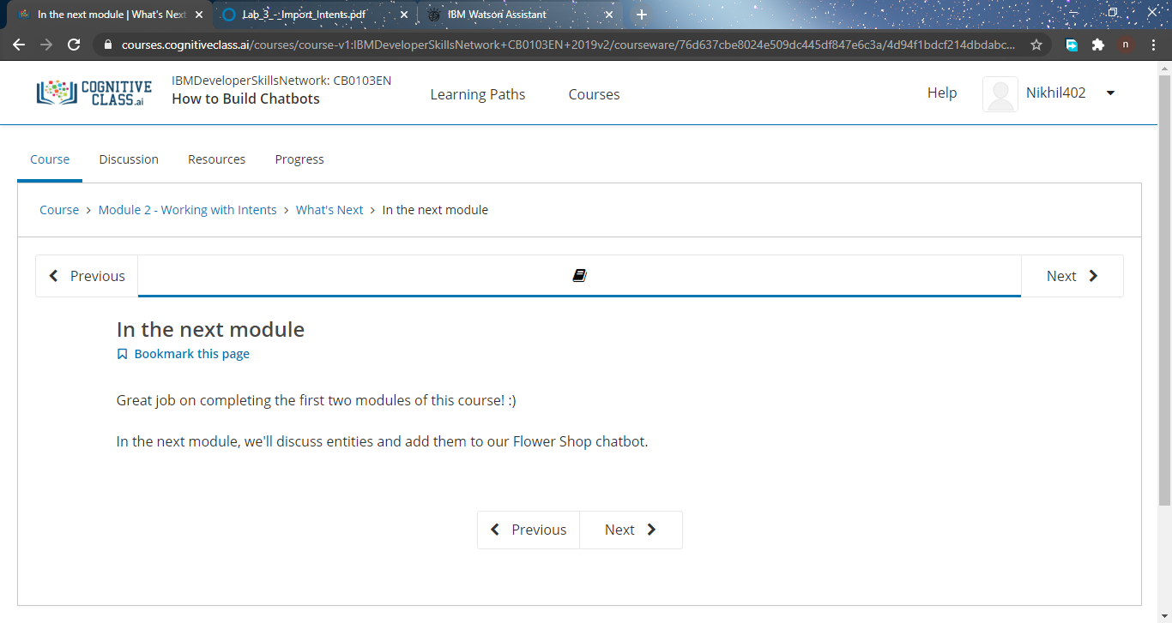Online Training : Today I had attended the online training organized by CSE Department AIET. The training was “Constructor Destructor, Inheritance“done by prof. Shruthi J shetty CSE Dept. After the session the quiz was conducted.**

**Snapshot is given below :**

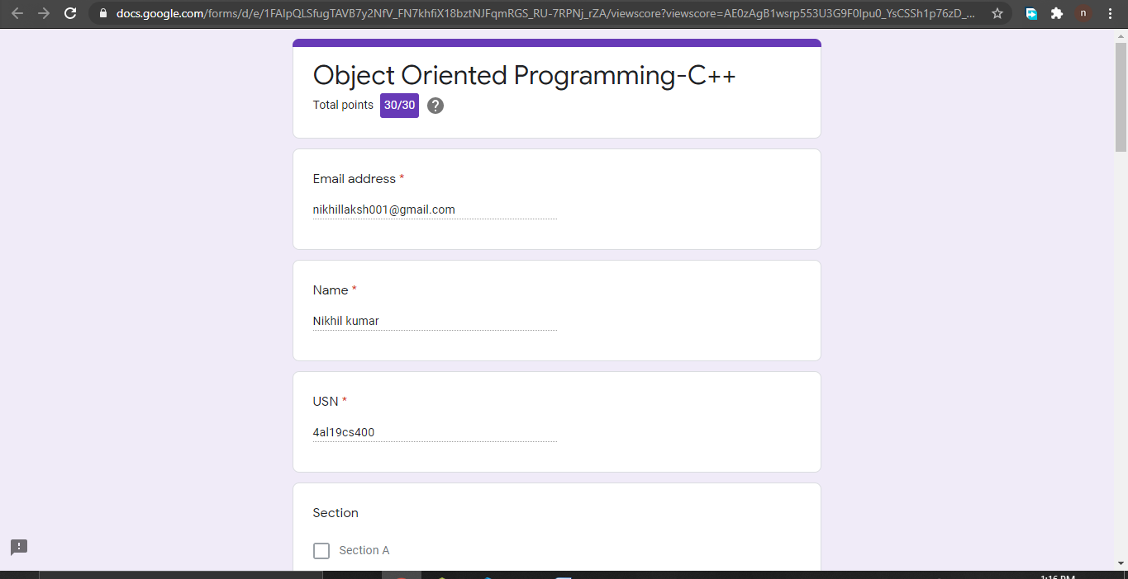

**Online coding summary: Today I had received programs which is mentioned in table above and I have uploaded into the github repository. Snapshot of the program is given below:**

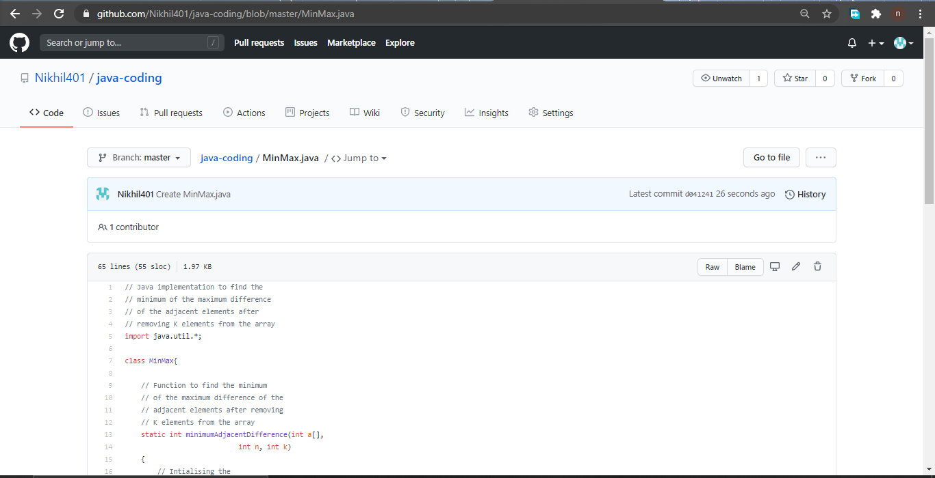 **Thank you.**